1. Mongodb Version depends on installation package that was used for MongoDB installation.
2. There may be version difference between MongoDB Server and MongoDB Shell.
3. 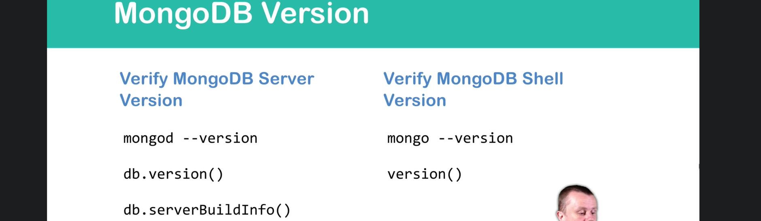
4. 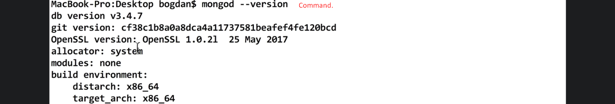
5. 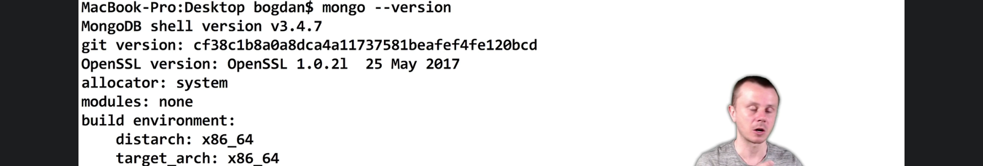
6. Not Complete but maybe not important.